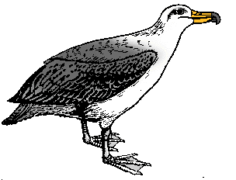
Albatross & Migration

Flys North in the Summer, and flys South in the Winter…

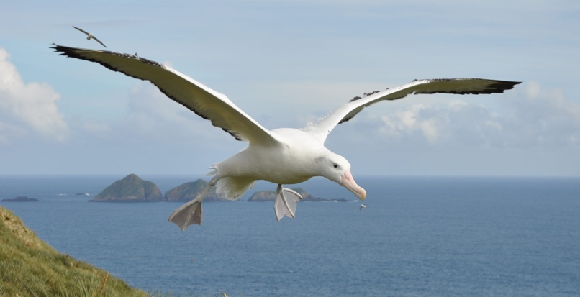
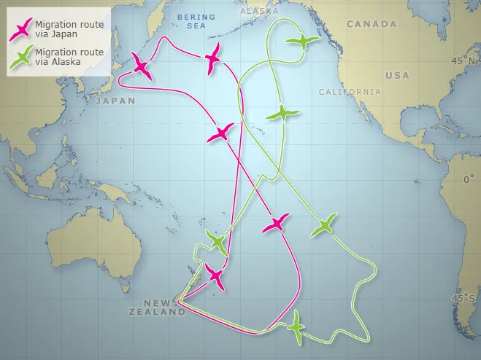

The Migration path is a “links in a chain”… they must stop every few now and then for food or etc.

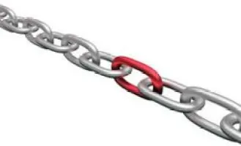

When one “Link” in the chain is broken eg. Someone wants to build a hotel there, the whole system of migration could collapse leading to their imminent disaster.

